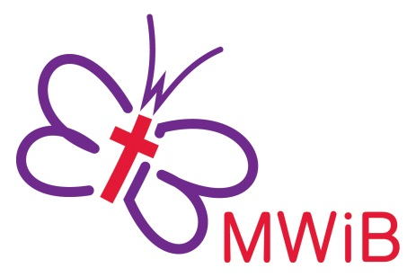
SOCIAL AND COMMUNITY
ACTION GRANT
APPLICATION – 2019

In 2019, the Finance Task Group of Methodist Women in Britain will use interest from the Welfare Fund to make grants for local projects around the UK. The aim is to foster active interest and involvement in social and community action and to encourage new projects. The total amount available for all grants will be approximately £6,000 – £7,000.

Guidelines

1. MWiB accepts applications, made through the MWiB District Forum Representative, for projects which meet the criteria as set out below.

a) Grants are intended to stimulate active interest and involvement in social and community action. Projects should meet a local social or community need particularly that of any group which would consider itself marginalised in society.
b) Priority will be given to projects which involve marginalised groups and to applicants seeking funding for imaginative new areas of work.
c) Grants are made only to Methodist, ecumenical or charitable projects. No more than one grant per circuit per annum can be supported.
d) Applicants must be committed financially or practically to the project.
e) Grants will not be given for building projects, staffing costs, ongoing expenses, or for other aspects of projects which generate heavy running costs.
f) Applicants must indicate the amount required and the specific purpose to which it will be applied. A budget must be attached.
g) The application must have the recommendation of the District Officers for Methodist Women in Britain.

2. The application form is available from District MWiB Forum Representatives, or from the Finance Officer at finance@mwib.org.uk It can also be downloaded from the MWiB website www.mwib.org.uk. The completed application form, signed by all signatories, should be scanned and returned electronically to the email address above by 28th February 2019. Alternatively a hard copy may be returned via your District Forum Representative and brought to the Forum meeting on 16th February 2019.

3. Please attach a full budget or detailed costs for the project to the application form

4. Where the application is successful, a full report, including confirmation that the grant was spent as described, must be submitted by the end of December 2019 to finance@mwib.org.uk . A copy of the report should also be sent to the District MWiB Treasurer.

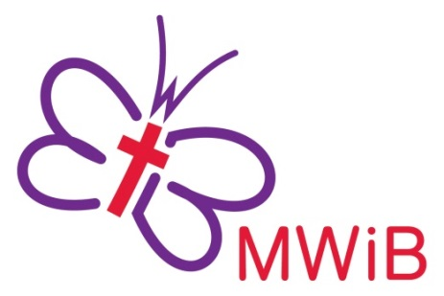
SOCIAL AND COMMUNITY
ACTION GRANT
APPLICATION – 2019

PLEASE TYPE OR USE BLOCK CAPITALS TO COMPLETE THIS FORM.
IT IS IMPORTANT THAT YOU ANSWER ALL THE QUESTIONS.

The completed application form should be returned electronically by 28th February 2019 to finance@mwib.org.uk or to your District Forum Representative in time for them to bring it to the Forum meeting on 16th February 2019

Name of District: District Number:

Name of Circuit: Circuit Number:

PROJECT NAME:
What is the project?

Project Address:
APPLICANT’S DETAILS
Name:
Address:
Postcode: | Tel No (inc STD Code):
E mail:
Signature:

PROJECT BANK DETAILS
Sort Code: |  | Account No:
Name on Bank Account
If your application is successful, the funds will be paid directly into this account with the reference MWiB SCA
This application must be supported by the MWiB District as evidenced by the following signatures:

1 | District MWiB Treasurer
 | Address:
 | Postcode: | Tel No (inc STD Code):
 | E-mail
 | Signature: | Date:
2 | Second District MWiB Officer:
 | Office held:
 | E-mail
 | Signature: | Date:
 | The District Committee for MWiB commends this project: Yes No
A representative of the District Committee for MWiB has visited this project or discussed it with the applicant:
Yes No

AMOUNT REQUESTED: | £

Please give details of how you propose to spend this grant. A fully costed budget or full details of the expenditure for the whole project must be attached to this application

PROJECT DETAILS

a) Explain what services your project provides, or hopes to provide.

b) How many people will benefit?

c) What particular Social or Community need does this project hope to address?

d) How regularly will it operate?

e) Is this a new initiative or part of an existing project?

d) What is the long-term aim of the project?

Please answer the following questions:
Have you applied for a Social & Community Action grant before? Yes No

Were you successful in the application? Yes No

If ‘yes’, state the year, amount and how the grant was used:

Was the grant used within the project to which this application refers? Yes No

Have you applied to any other funding bodies, organisations or sponsors?
If ‘yes’, please give name, date of application, the amount requested or given:

If ‘no’, please give reasons:

What is the present financial involvement or commitment of Methodist and/or other women to the project?

If working with children or vulnerable adults, can you confirm that the church has completed successful CRB screening for all volunteers involved?
Yes No

If preparing food, please can you confirm that those involved have hygiene certificates?
Yes No

PLEASE ATTACH YOUR BUDGET OR DETAILS OF YOUR COSTS TO THIS APPLICATION, INDICATING HOW THE INCOME FROM THIS GRANT WILL BE SPENT.

