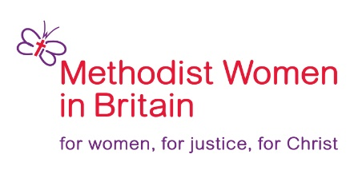
ENABLING GRANT

MWiB Enabling Grant:-
Methodist Women in Britain have set aside monies to provide Enabling Grants to empower women and/or girls to open opportunities for the development of their Christian ministry in a practical way at home or abroad. A grant will be a one-off contribution towards part of the funding. It is assumed that either there will be some self-funding from the applicant, or other contributions from elsewhere to fund the full cost of specified Enabling Opportunities. Applicants are invited to apply for a grant if the following criteria are met:
Criteria:-
- The applicant should be a Methodist woman or associated with a Methodist group.
- The application must be supported by a Methodist referee (e.g. a Methodist Presbyter, Deacon or MWiB Officer).
- The application must comply with the aims and objectives of MWiB – see attachment.
- The grant may be used to purchase IT equipment where this aids the access to training materials but otherwise the grant is not available for capital expenditure (e.g. building work).
- Applications to fund or part fund salaries will not be considered
- The grant is only available for new initiatives.
- The application must show that the grant will be used to empower the applicant and develop their Christian ministry.
- Applications to be submitted to the Enabling Grant Group (EGG). See the contact details below.

The application will need to show:-
- Clear planning with identifiable outcomes.
- That the applicant is able to fund that part of the costs not covered by this grant.
- A comprehensive, planned and fully costed budget for the duration of the project.
- How this work is to be monitored, demonstrating rigorous accountability, costing and transparency.

REPORTING
A report will be required to show how this work has opened opportunities for the development of the applicant’s Christian ministry in a practical way. This may be submitted at any time but a final account must be submitted at the end of the project.
Any unused grant is to be returned to MWiB.
Applications may be submitted electronically to finance.mwib@gmail.com or by post to:-
Finance Officer C/o Touchstone, 4 Easby Road, Bradford, W. Yorks. BD7 1QX
For further information please use the above email address or telephone 0300 030 9873.

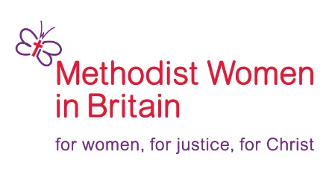
APPLICATON FORM FOR THE MWiB
ENABLING GRANT

Methodist Women in Britain have set aside monies to provide Enabling Grants to empower women and/or girls to open opportunities for the development of their Christian ministry in a practical way at home or abroad. You are invited to apply for a grant if you can meet all the criteria set out above.

APPLICANTS DETAILS:
Name

Address

Telephone or mobile

Email address

District | Circuit
Church Name

Summary of Enabling Opportunity

BANK DETAILS: (We will use these details to pay the grant if your application is successful)
Account Number | Sort Code
Name on the Account

Amount of Grant required (This should agree to the figure shown below) *

REFEREE DETAILS:
Name | Signature
Position in the Methodist Church

Comments in support of the application

DETAILS OF ENABLING OPPORTUNITY:
Details of the work

Identifiable outcomes

How this work will be monitored (e.g. through mentoring, or through regular reports or meetings)

Proposed budget (Please include here the costs of all training, travel, and other resources that will be required to enable you to complete the proposed project)

Total Costs | £
Total grant applied for (see above)* | £
Balance to be covered by Other Funding | £
Details of how this balance will be Funded

Signature of Applicant | Date

Please return completed form as an email attachment to finance.mwib@gmail.com or by post to Finance Officer C/o 4 Easby Road, Bradford, Yorks. BD7 1QX
If you need any further information please email finance.mwib@gmail.com or telephone 0300 030 9873

