International Day for the Elimination of Violence Against Women 25 Nov 24

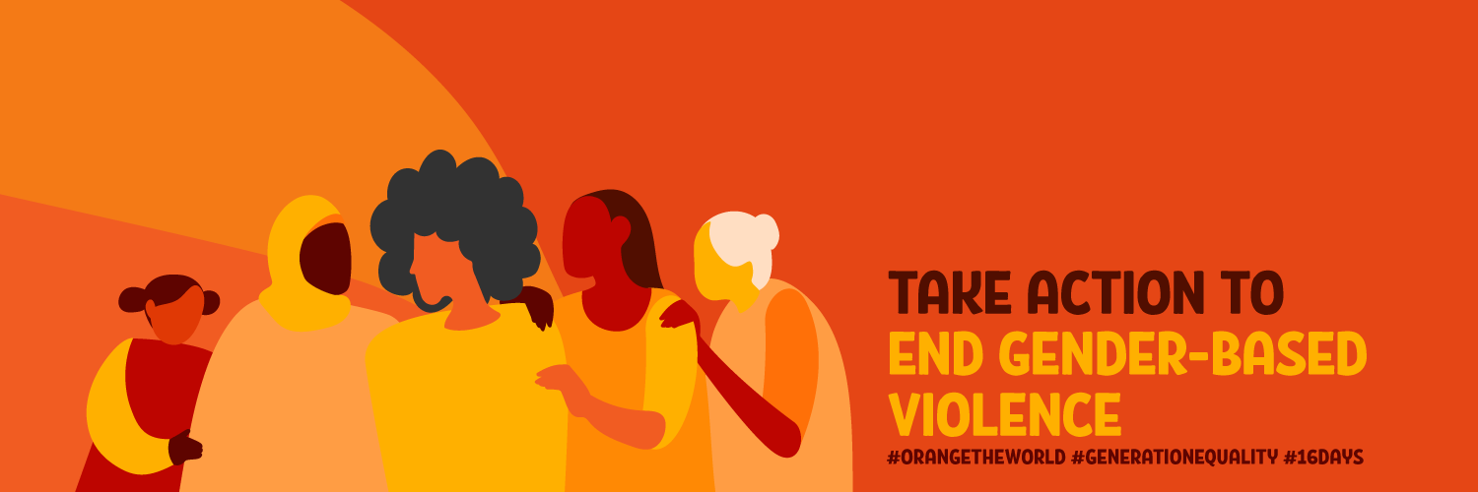

“Nowhere in the world is a woman safe from violence. The strengthening of global commitment to counteract this plague is a movement whose time has come.”-Asha-Rose Migiro

Women's rights activists have observed 25 November as a day against gender-based violence since 1981. This date was selected to honour the Mirabal sisters, three political activists from the Dominican Republic who were brutally murdered in 1960 by order of the country’s ruler, Rafael Trujillo (1930-1961).

On 20 December 1993, the General Assembly adopts the Declaration on the Elimination of Violence against Women through resolution 48/104, paving the path towards eradicating violence against women and girls worldwide.
Finally, on 7 February 2000, the General Assembly adopts resolution 54/134, officially designating 25 November as the International day for the Elimination of Violence Against Women and in doing so, inviting governments, international organizations as well as NGOs to join together and organize activities designed to raise public awareness of the issue every year on that date.

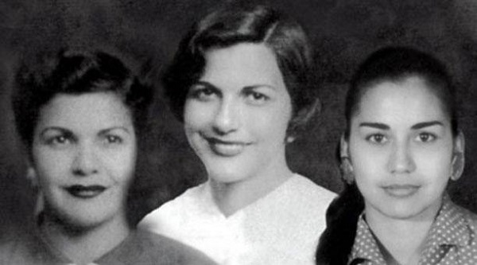

Patria, Minerva and Maria Teresa lived in the Dominican Republic under the dictatorship of Rafael Trujillo. The regime was brutal with dissidents being imprisoned, tortured and murdered.

Despite the many threats to their safety, the sisters led an underground movement which challenged the cruel and systematic violence. They distributed leaflets naming those who had been killed.

On 25 November 1960, the three sisters were clubbed to death, their bodies placed in their vehicle and run off the road making it look like an accident.
The murders caused such outrage, that within 6 months Trujillo was assassinated. The sisters became a symbol of democratic and feminist resistance and became known as “The Butterflies”

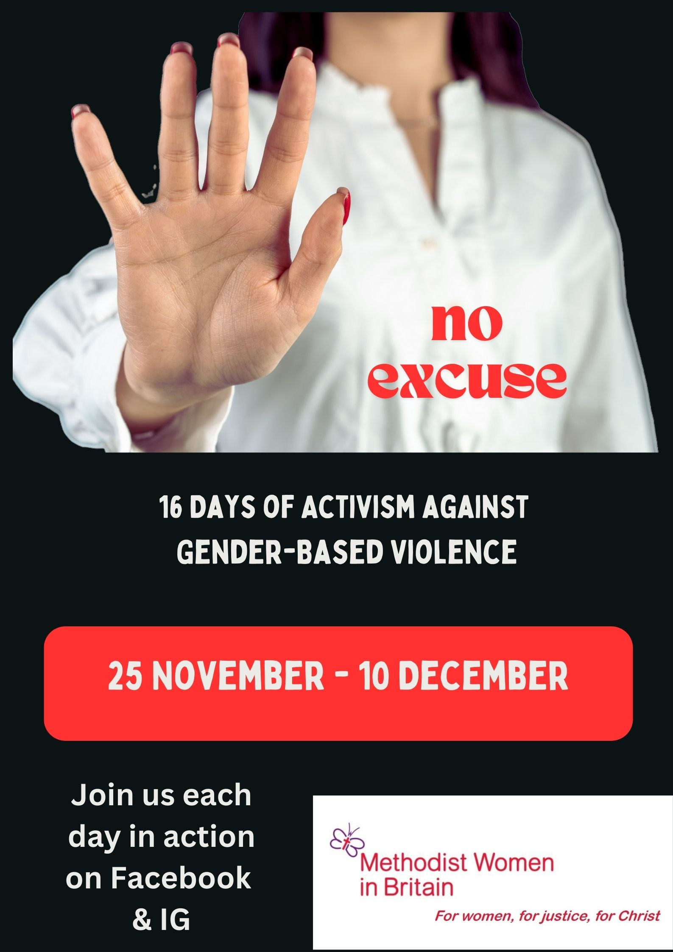

Every 10 min in the world In 2023, a woman was killed. Such murders are qualified as gender-based violence and are the most prevalent form of human rights violation in the world.
1 in 3 women experience violence in their lifetime.
Women who have experienced violence are more likely to suffer from depression, anxiety disorders, unplanned pregnancies, sexually transmitted infections, and HIV, with long-lasting consequences.

“Methodist Women in Britain wish to stand alongside all caught up in gender-based violence. No one should live in fear of violence because of their gender. As a global movement, we can effect change by amplifying the voices of those experiencing violence. We need to speak up and speak out, challenging long-held practices and beliefs. We invite all to join us in the 16 Days of Activism. You can find the Daily Action on our Facebook page and Instagram account.

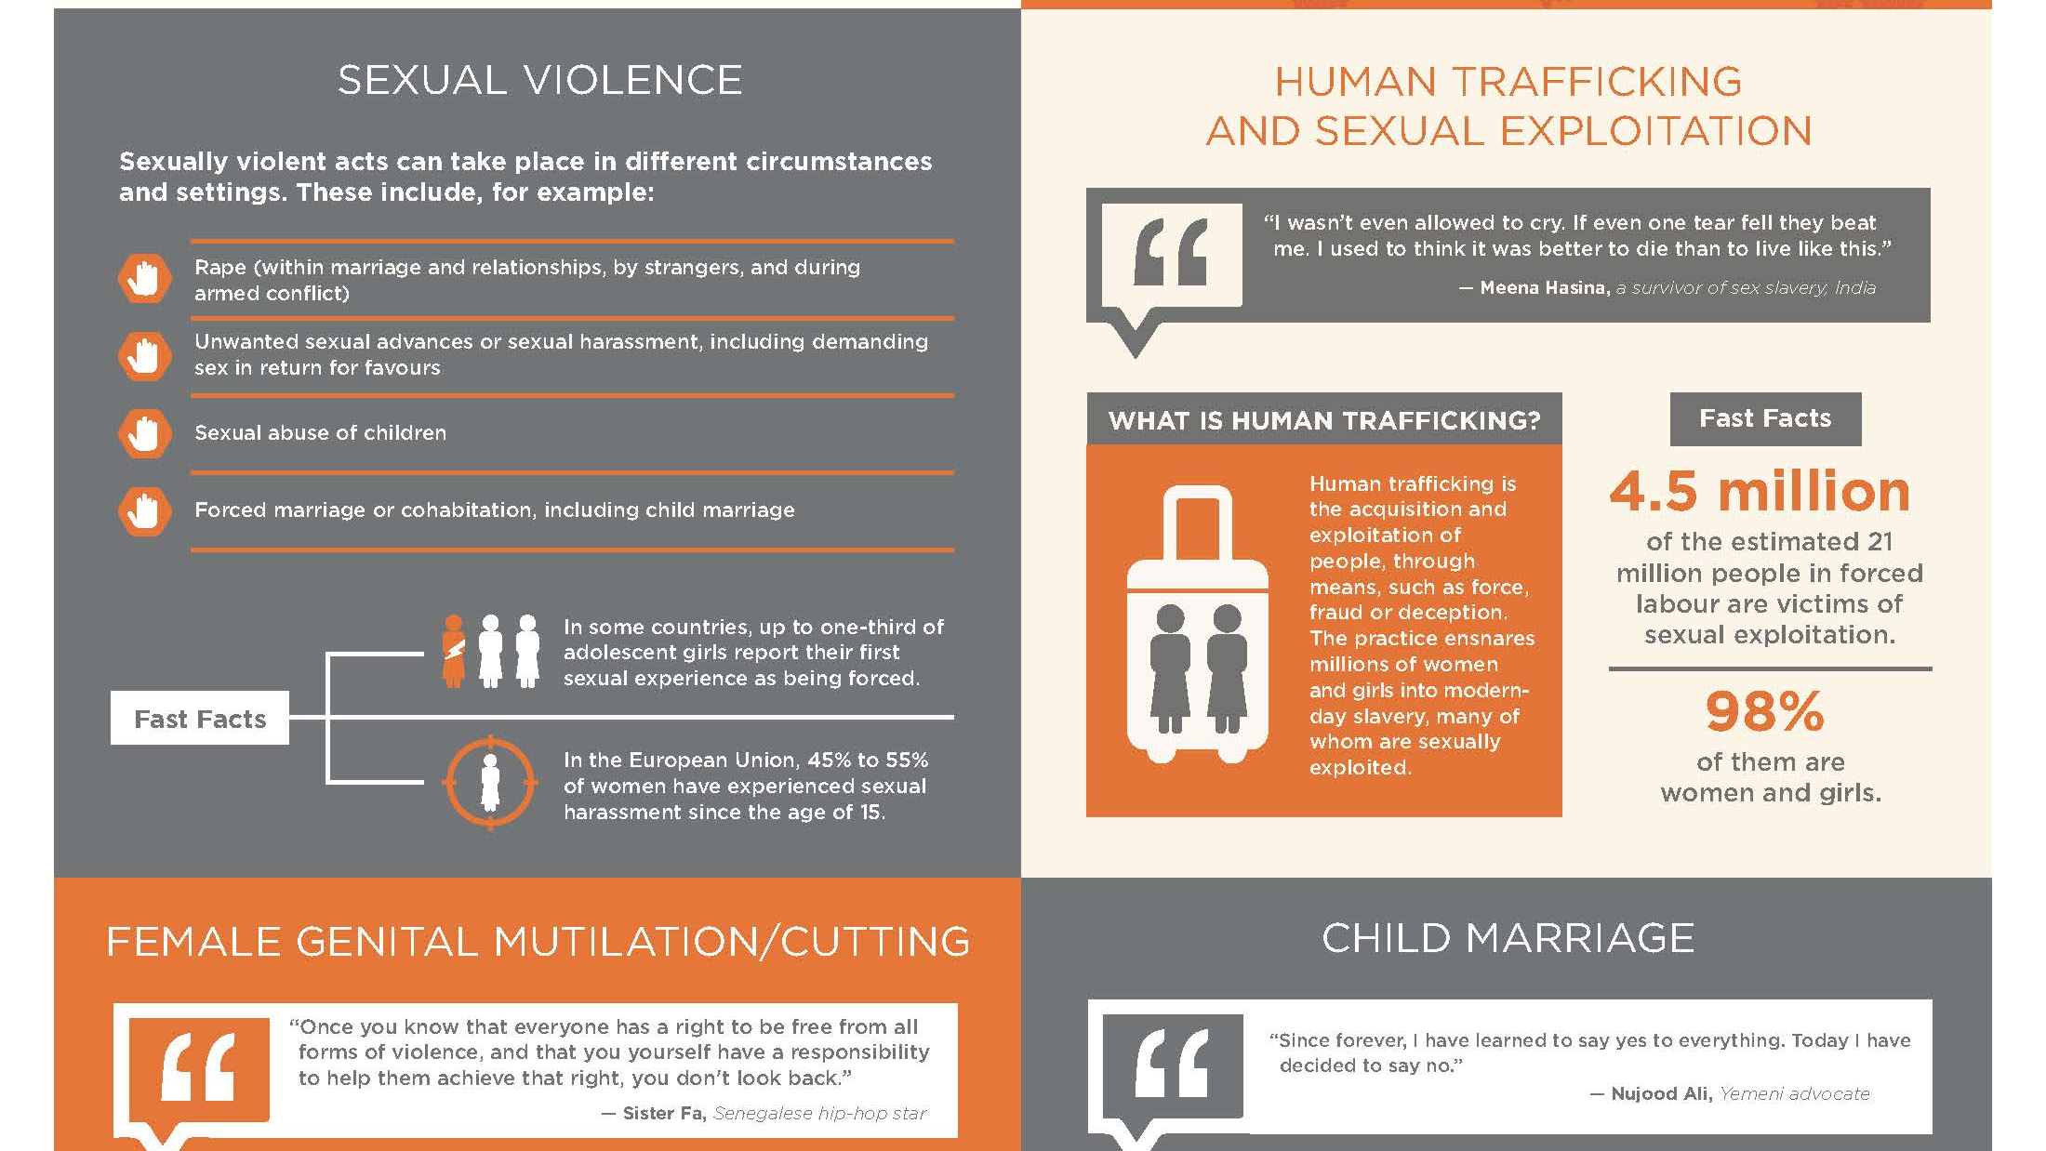
This Photo by Unknown Author is licensed under CC BY-NC-ND

Light a candle at 7pm
Join in prayer
Take action

#NoExcuse. UNiTE to End Violence against Women.

