WELCOME and HELLO!

Overview: Welcome to your ‘Whose Bag Is It Anyway?’ pack. Included are six handouts; each one provides a template for your sessions. However, feel free to be creative as you like and include your own resources/speakers too. We suggest between 1.15-1.30hr for each session depending on size of group/venue etc.

Overarching session aims:

To discover something new about the different faith traditions and their teachings around caring for creation.

To take part in environmentally friendly, creative and though-provoking activities.

To be inspired and empowered to take positive action.
Session format:
- Pause for thought (feedback from previous session/conversation starter).
- Talks. Links below from recordings made at the ‘Interfaith Environment Conference, 2022’.
- Creative activity/action.
- Closing reflection/meditation.
- Take home resource/link (optional).

Online resources: (permission to share from all providers). Faith perspectives on caring for creation.

Session One: The Loving Earth Project Meditation

https://www.youtube.com/watch?v=0FKc5nRV-Bc

Session Two: (Jewish) Andrea Passe - EcoSynagogue
https://youtu.be/pUCxoi6WcGo

Session Three: (Christian) Hannah Brown - Joint Public Issues Team
https://youtu.be/dqUFmcFnPHk

Session Four: (Muslim) Rabiah Mali - Green Deen Tribe
https://youtu.be/87iImkuVWMI

Session Five: (Sikh) Amandeep Maan - EcoSikh
https://youtu.be/LgWh7lN4EYw

Session Six: (Hindu) Interfaith Perspectives on the Environment - Natasha Chawla - Hindu Climate Action
https://youtu.be/Ib4NUNDRR9E

Session One: Introduction
Pause for thought (in pairs): What’s your earth story? You are invited to share memories of any connections you’ve made with ‘the earth’, e.g. gardening, walks, swimming outdoors, flooding, de-forestation. Feedback.

Talk: A guided meditation from ‘The Loving Earth Project’ (http://lovingearth-project.uk). The project celebrates some of the wonderful things threatened by environmental breakdown. A community textile project is a central part of the project. Making a textile panel creates space for creative reflection. As you watch this meditation, you may begin thinking about your tote bag design. Questions for discussion:

Is there something, someone or somewhere that you know and love which is endangered by environmental breakdown?

How does your lifestyle contribute to that threat?
- What could you do, or are you doing, to help reduce that threat?
Creative activity/action: Create the design for your tote bag. Perhaps find recycled paper to draw your images on and then begin to think about bringing in old materials to share next time. Over the week, items to collect may include; fabric paints/pens, needle and thread, wool, fabric glue, natural materials etc.
Closing reflection/meditation:
We Hold the Earth (Interfaith Climate Prayer)
We hold brothers and sisters who suffer from storms and droughts intensified by climate change.
We hold all species that suffer.
We hold world leaders delegated to make decisions for life.
We pray that the web of life may be mended through courageous actions to limit carbon emissions.
We pray for right actions for adaptation and mitigation to help our already suffering earth community.
We pray that love and wisdom might inspire my actions and our actions as communities. . .
so that we may, with integrity, look into the eyes of brothers and sisters and all beings and truthfully
say, we are doing our part to care for them and the future of the children.
May love transform us and our world with new steps toward life
(from Prayers and Climate Blessings (faithclimateactionweek.org))
Take home resource/link:
Participants can complete the following carbon calculator at home. https://www.carbonindependent.org/

Session Two: A Jewish Perspective
Pause for thought: Group feedback in relation to actions/reflections since the previous session.
Talk: Andrea Passe - EcoSynagogue
In the group or in pairs: What is something new I have learned from listening to this talk?
What similarities can I see between this faith tradition and my own when it comes to caring for creation?
Creative activity/action: Transferring completed design from session one on to tote bags.
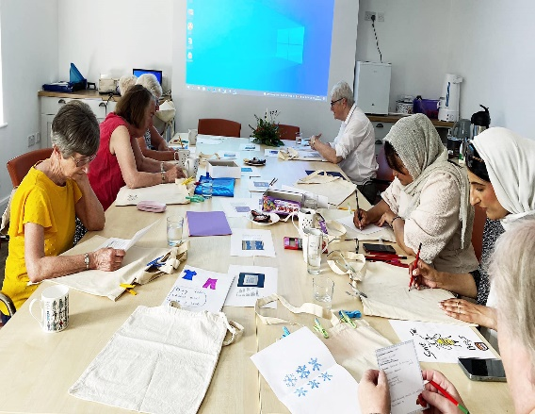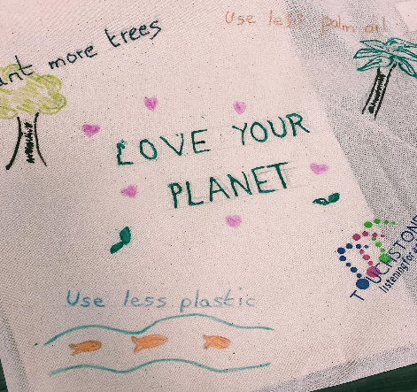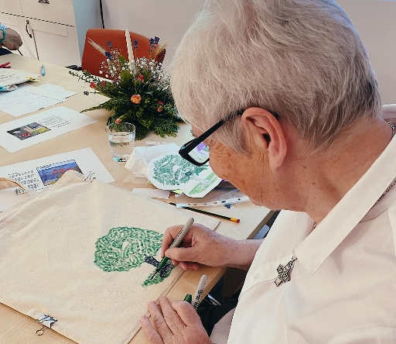
Closing reflection/meditation: Extract taken from ‘A Prayer for Our Planet’, San Diego Jewish World.
Dear God, may we do our share in assuring that how we live and what we support is not contributing to disproportionate impacts on the health, shelter and food supplies for our most vulnerable populations.
For the sake of our children, grandchildren and further generations, may we listen to the cry of today’s youth about their survival on our planet. May we support science-based measures and wise global strategies to reverse the direction our climate is headed.
May our Jewish tradition of valuing life, the environment and justice guide us. May it encourage us to be strong leaders in emerging worldwide, multi-faith climate and environmental justice movements. And let us say, Amen (By Dan Tomsky, https://www.sdjewishworld.com/2021/10/31/a-prayer-for-our-planet/)
Take home resource/link:
Read through 10 pledges to help reduce the impact we may have on the environment. Thanks to the Anglican Diocese of Leeds for permission to share.
https://learning.leeds.anglican.org/resource/the-10-pledges/

Session Three: A Christian Perspective
Pause for thought: Where do you go to ‘be in nature’? What helps and/or hinders the ‘greener spaces’ near where you live? Discuss.
Talk: Hannah Brown - Joint Public Issues Team (Methodist Church of Great Britain).
In the group or in pairs: What is something new I have learned from listening to this talk?
What similarities can I see between this faith tradition and my own when it comes to caring for creation?
Creative activity/action:
First, explore together how people may already care for wildlife in their homes/towns/cities?
The link below (RSPB - Royal Society for the Protection of Birds) is about why and how to create a wildlife friendly garden. This may prompt further conversations. You may then wish to make a bug hotel or plant some wild flowers in response.
https://www.rspb.org.uk/birds-and-wildlife/advice/gardening-for-wildlife/creating-a-wildlife-friendly-garden/
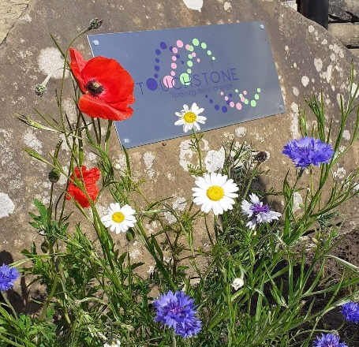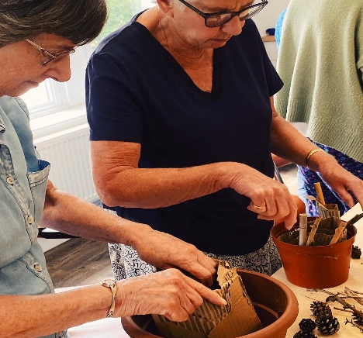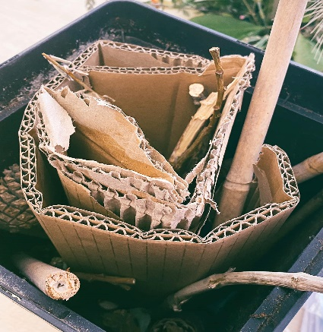
https://www.redtedart.com/simple-bug-hotel-for-kids/
https://www.youtube.com/watch?v=Smv_9vgN39A
Closing reflection/meditation: Extract taken from Christian prayers for the environment/Christian Aid, ‘Our Prayer for a Just and Fair Future’.
Great Spirit, heavenly Father, source of life and love.
We rejoice and give thanks for your bountiful planet. Great plains, verdant forests, deserts of rock, sand and ice, mountain ranges, rivers and oceans: ecosystems to meet the needs of all your creatures.
Awaken us to our true nature, to live in peace with you, each other and all creation. By restoring harmony and balance we too will be restored to wholeness.
Amen.
(by Bishop Geoff Davies and Kate Davies https://www.christianaid.org.uk/sites/default/files/2021-07/Our%20Prayer%20for%20a%20Just%20and%20Fair%20Future.pdf)
Take home link/resource: More activities/ideas on the RSPB website.
https://www.rspb.org.uk/birds-and-wildlife/advice/gardening-for-wildlife

Session 4: A Muslim Perspective
Pause for thought: Group feedback in relation to actions/reflections since the previous session.
Talk: Rabiah Mali - Green Deen Tribe.
As a group or in pairs: What is something new I have learned from listening to this talk?
What similarities can I see between this faith tradition and my own when it comes to caring for creation?
Creative activity/action: https://craftivist-collective.com/our-story/
What is craftivism? One definition comes from Sarah Corbett’s book ‘How to be a craftivist: the art of gentle protest’. The book is a manifesto for quiet activism. Sarah’s story is about being a burnt-out activist who was tired of marching, confrontation and demonizing opposition, towards a more respectful activism. Sarah now uses craft to contemplate global issues and start conversations rather than arguments. It is about bringing out the best in one another and encouraging challenge in a respectful and emotionally intelligent way. Craftivism can be for everyone and you can start small.
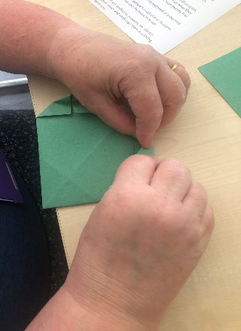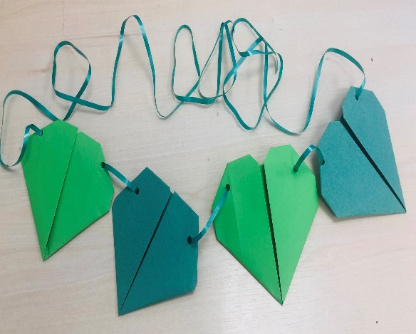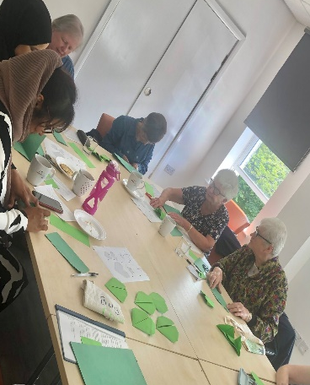
Making green hearts: The green heart has become the symbol for loving the planet.
http://www.supercoloring.com/paper-crafts/origami-heart-instructions
As you mindfully craft your hearts (paper folding, sewing, knitting etc) you may think of someone you could share your green heart with this week. Alternatively, you may wish to design a display in your community/worship space to highlight some of the ‘Whose Bag is it Anyway?’ topics.
For more ideas/patterns/links: Leeds Sanctuary (formerly LMM) resources from Climate Sunday. https://leedsmethodistmission.wordpress.com/2021/03/25/green-hearts-climate-sunday/
Closing reflection/meditation: Extract taken from Islamic prayers on the Australian Religious Response to Climate Change https://www.arrcc.org.au/reflect-prayers-islamic
Oh Allah, You are the Creator, the All-Powerful, the Sustainer of all life. Forgive us for being careless with Your earth
that you created in perfect measure and balance.
Forgive us for not recognising the wisdom
in the Creation of every species.
Forgive us for taking and using your Creation
to satisfy our selfish desires, rather than our needs. Please forgive us Ya-Ghaffar (O All-Forgiving One).
Take home link/resource: Craftivist Collective https://craftivist-collective.com/
Session 5: A Sikh Perspective/ Climate Change and Refugees
Pause for thought: What does the title of today’s session evoke in you?
Talk one: Amandeep Maan - EcoSikh.
As a group or in pairs: What is something new I have learned from listening to this talk?
What similarities can I see between this faith tradition and my own when it comes to caring for creation?
Talk two: Listen to ‘Dear Matefele Peinim’ – a UN Climate Summit Poem (by Kathy Jetnil-Kijiner, a poet and climate change activist) from the Marshall Islands (one of the most climate vulnerable nations on earth).
https://www.youtube.com/watch?v=DJuRjy9k7GA
Creative activity/action: Creating a ‘Prayer Wall of Hope’ with ideas from Christian Aid.
https://www.christianaid.org.uk/sites/default/files/2021-02/Prayer%20Wall%20of%20Hope__0.pdf
It can be as simple as writing thoughts/prayers down together on paper, or pinning ribbons and fabric to a suitable board/gate. In the light of this session, perhaps think about how the climate crisis impacts migration/refugees/the world.
Alternatively, some people may wish to write their own poem on the themes raised in today’s session.
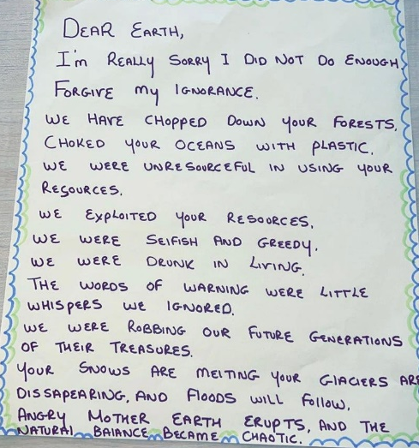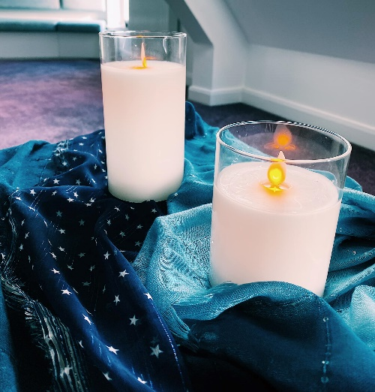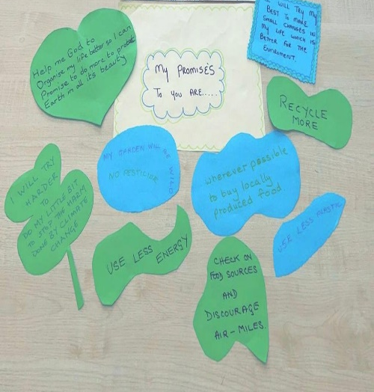
Closing reflection/meditation: Take a moment to pause and hold silence together in front of your work.
Take home link/resource:
Oxfam Research Report- ‘Uprooted by Climate Change: responding to the growing risk of displacement’. An accessible report about the relationship between climate change and displacement, including case studies from different parts of the world.
https://www-cdn.oxfam.org/s3fs-public/file_attachments/bp-uprooted-climate-change-displacement-021117-en.pdf

Session 6: A Hindu Perspective
Pause for thought: How are you feeling as you come to the final session? What questions/thoughts about caring for creation are still on your mind and heart? Gather group feedback.
Talk: Natasha Chawla- Hindu Climate Action.
As a group or in pairs: What is something new I have learned from listening to this talk?
What similarities can I see between this faith tradition and my own when it comes to caring for creation?
Creative activity/action: In advance and as a group, decide on a practical activity for today.
Ideas may include: a prayer walk, litter pick, planting a tree, writing to your MP.

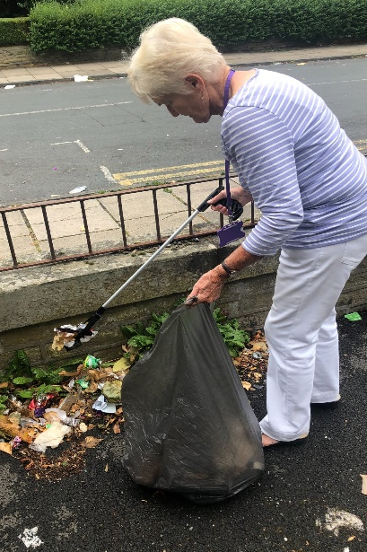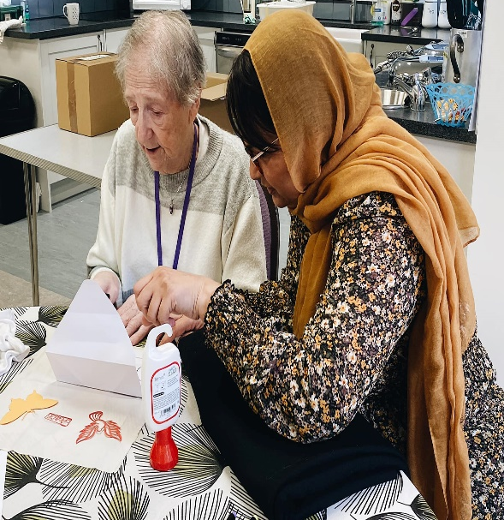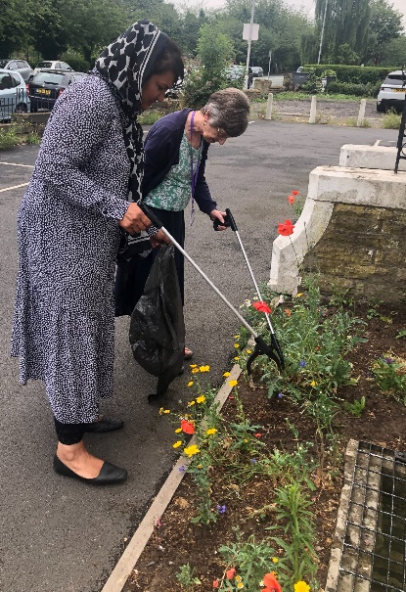

Closing reflection/meditation:
Hindu prayers for the environment extracted from https://www.arrcc.org.au/reflect-prayers-hindu

Prayer to Mother Earth for Grace
“Earth in which the seas, the rivers and many waters lie,
from which arise foods and fields of grain,
abode to all that breathes and moves,
may She confer on us Her finest yield.”
— Bhumi Suktam, Atharva Veda xii.1.3

(Source: Hindu Declaration on Climate Change)

Closing thanks: Each person says one thing they are thankful for in relation to ‘Whose Bag is it Anyway?’.

