30th August | Safe travelling for all returning home from WFMUCW World Assembly & newly appointed Officers On this day in 1797, Mary Shelley was born. Let’s give thanks to women writers and artists who forged the way for other women in the arts, and for our foremothers who fought for rights and privileges which were already offered to men to be extended to women.
6th Sept | On this day in 1968, Swaziland, now Eswatini, became independent. Let’s pray for countries still suffering the ramifications of colonialism, and let’s pray and give thanks for those peoples who, being now free, are rebuilding their unique identity.
13th Sept | 14th Trustees & Ambassadors meeting on zoom 16th Philippa in Monton Methodist, Manchester  On this day in 1933, Elizabeth McCombs became the first woman elected to the New Zealand Parliament. Let’s give thanks today for the progress made towards female representation in politics, and let’s continue to pray for equal representation and a safe working environment in politics across the globe.
20th Sept | On this day in 1973, Billie Jean King won the Battle of the Sexes tennis match at the Houston Astrodome. Let’s give thanks today for women in sports and the opening up of traditionally masculine spaces to women. Let’s continue to pray for those areas that are still unjustly barred to women.
27th Sept | On this day in 2007, NASA launched the Dawn probe to the asteroid belt. Let’s pray for scientists around the world as they continue to explore and reveal the wonders of God’s creation and genius.
4th Oct | 9th-11th Trustee Board meeting, Eastwood Hall, Nottingham  As the trustees meet this week, let’s pray for the future of MWiB. Let’s pray especially for the new Trustee Board, District ambassadors and Finance & Swanwick task groups as they seek to maintain cohesion and vision in a diverse, intergenerational, and transforming context.
11th Oct | 17th World Federation Day, Stapleford Methodist Church, Nottingham  Let’s pray for the World Federation as we approach its birthday, remembering all the women who have worked hard for this international sisterhood of women promoting Christ and Christ’s love.
18th Oct | On this day in 1929, the Edwards v. Canada case declared women as ‘Persons’ under Canadian law. Let’s pray for women across the world who are not considered people. Let’s pray for all those groups who will benefit from MWiB Empowerment Gifts this year, using them to empower women and girls.
25th Oct | On this day in 1940, Benjamin O. Davies Sr. was named the first African American general in the US army. Let’s pray for places where discrimination is still practiced, especially where racism is systemic.
1st Nov | All Saints Day  On this day in 1848 in Boston, USA, the first medical school for women was opened. Let’s pray for girls’ and women’s education worldwide, and for those who have been barred from schools.
8th Nov | Remembrance Day; 9th Trustees Board meeting on zoom; 11th Olive in Exeter, SW Peninsular  On this day in 1901, the Gospel Riots took place in Athens, where there was bloodshed over the translation of the Gospels into demotic Greek, which is the modern standard language of Greece. Let’s give thanks for the different translations of Scripture, and let’s pray for those who continue to translate it into new languages and dialects to make it accessible to more and more people.
15th Nov | On this day in 1971, the first ever single-chip microprocessor, the 4004, was released by Intel Corporation in the USA. Let’s pray for the technological advancements being made to be safe, helpful, and appropriate.
22nd Nov | 16 Days of Activism start 25th  The 16 Days of Activism against Gender-Based Violence begin with the International Day for the Elimination of Violence against Women on the 25th and will run on to Human Rights Day on 10th December. Let’s pray for women across the globe who suffer violence and abuse. We pray that the Butterfly Service may be used widely across the connexion to spread a message of hope & support.
29th Nov | Advent Sunday  On this day in 1961, a chimpanzee called Enos was launched into space, orbiting the Earth twice before landing off the coast of Puerto Rico. Let’s pray today for an end to animal cruelty and abuse, especially those acts which are done in the name of good things like science or medicine.
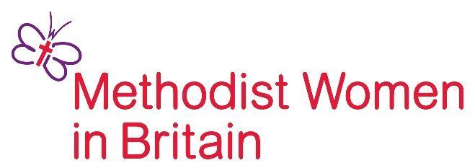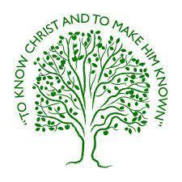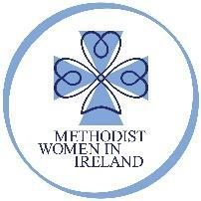
for women, for justice, for Christ The British Unit of the World Federation of Methodist & Uniting Church Women
Prayer Diary
September to November 2026
Join us in praying for Methodist Women in Britain Trustees & District Ambassadors,
Methodist Women in Ireland and the World Federation of Methodist & Uniting Church Women
as well as the work of Methodist Women in Britain across our Districts.
Our prayer diary can be used alongside the Methodist Church Prayer Handbook.

Day 1 | Methodist Women in Britain Chair: Olive Ruzvidzo & Vice Chair: Philippa Hill
Day 2 | London District Ambassadors & MWiB activities
Day 3 | West Midlands District Ambassadors & MWiB activities
Day 4 | Bedfordshire, Essex & Hertfordshire District Ambassadors & MWiB activities
Day 5 | South East District Ambassadors & MWiB activities
Day 6 | MWiB Trustee Leads: Finance Sheila Hall & Resources and Fundraising Caroline Fillery
Day 7 | Bristol District Ambassadors & MWiB activities
Day 8 | The Methodist Church in Wales/Cymru District Ambassadors
Day 9 | MWiB Trustee Leads: Communications Bronwen Braisdell & Safeguarding Ruth Dawson
Day 10 | Channel Islands District Ambassadors & MWiB activities
Day 11 | Chester and Stoke on Trent District Ambassadors & MWiB activities
Day 12 | South West Peninsular District Ambassadors & MWiB activities
Day 13 | Darlington District Ambassadors & MWiB activities
Day 14 | East Anglia District Ambassadors & MWiB activities
Day 15 | Isle of Man District & Manx Methodist Women
Day 16 | Methodist Church in Ireland and Methodist Women in Ireland
Day 17 | Lincolnshire District Ambassadors & MWiB activities
Day 18 | MWiB Trustee Lead: Governance and Administration Gillian Pengelly
Day 19 | MWiB Trustee Leads: Events & People and Volunteering – Vacancies – is God calling you?
Day 20 | Newcastle upon Tyne District Ambassadors & MWiB activities
Day 21 | WFMUCW (B&I) Area President & Vice President: Wanda Hogan & Helen Cunningham
Day 22 | Nottingham and Derby District Ambassadors & MWiB activities
Day23 | Northampton District Ambassadors & MWiB activities
Day 24 | North West England District Ambassadors & MWiB activities
Day 25 | Sheffield District Ambassadors & MWiB activities
Day 26 | Southampton District Ambassadors & MWiB activities
Day 27 | Yorkshire West District Ambassadors & MWiB activities
Day 28 | Helen Kim Scholars Britain & Ireland: Izzy Solomon & Hope Graham
Day 29 | Yorkshire North and East District Ambassadors & MWiB activities
Day 30 | Scotland and Shetland District Ambassadors & MWiB activities
Day 31 | WFMUCW World President, Vice President (tbc) & President Emerita: Sipiwe Chisvo

What a privilege to carry everything to God in prayer
(Prayer focus this quarter prepared by Madeleine Reed, former Helen Kim Memorial Scholar)

